**SOFTWARE REQUIREMENT SPECIFICATION**

**DOCUMENT**

**CALCULATOR SYSTEM**

**Version:** Version 2.0



**ABSTRACT**

This document is intended to be the SRS for develop **CALCULATOR SYSTEM**



| **Project Title** | **CALCULATOR SYSTEM** | | |
| --- | --- | --- | --- |
| **Lead Institution** | **THE INTERNATIONAL SCHOOL - DUY TAN UNIVERSITY** | | |
| **Project Mentor** | **Mr. Nguyen Dang Quang Huy** | | |
| **Team Name** | **Team 4** | | |
| **Team Members** | **Vo Trung Hieu** | | |
| **Truong Minh Quang** | | |
| **Nguyen Thi Kim Hue** | | |
| **Le Thi Thanh Huyen** | | |
| **Tran Dinh Huy Hoang** | | |
| **Start Date** | Jan 22,2024 | **End Date** | Jan 22,2024 |

**ROPRIETARY INFORMATION**: The information contained in this document is the property of **TEAM 4**. Except as specifically authorized in writing by **TEAM 4**, the holder of this document shall keep all information contained herein confidential and shall protect same in whole or in part from disclosure and dissemination to all third parties

**Table of Contents**

Revision History 4

1. Introduction 5

1.1. Purpose 5

1.2. Intended Audience and Reading Suggestions 5

1.3. References 5

2. Project Overview 5

2.1. Project Description 5

2.2. Business Need 5

2.3. Project Analyst 6

2.3.1. Business Function Diagram 6

2.3.2. System Context Diagram 6

2.4. Software Requirement Specification 7

2.4.1. High level Functional Requirement (FR) 7

2.4.2. Stakeholders 7

2.4.3. Use case 8

2.4.4. List of use case 8

UC 01: Addition 8

UC 02: Subtraction 9

UC 03: Multiplication 10

UC 04: Division 12

UC 05: Mod 12

2.4.6 . Activity Diagrams 14

2.4.6.1. Addition 14

2.4.6.2. Subtraction 15

2.4.6.3. Multiplication 16

2.4.6.4. Division 17

2.4.6.5. Mod 18

Appendix A: Glossary 18

# Revision History

| **Date** | **Change Iterm** | **Description** | **by** | **Version** |
| --- | --- | --- | --- | --- |
| **22/1/2024** | Start team meeting | Meet and refer to a number of training points, read through the training points and focus on project implementation, the team can fully understand the system requirements to create | Vo Trung Hieu, Nguyen Thi Kim Hue, Truong Minh Quang, Le Thi Thanh Huyen, Tran Dinh Huy Hoang | Version 1.0 |
| **22/1/2024** | Job analysis | Through specific requirements, analysis, clearly speaking, the leader needs to prepare in advance for the members. | Vo Trung Hieu, Nguyen Thi Kim Hue, Truong Minh Quang, Le Thi Thanh Huyen, Tran Dinh Huy Hoang | Version 1.0 |
| **22/1/2024** | Share the work | Get BFD, contextual diagram. The mandatory rules of the project | Vo Trung Hieu, Nguyen Thi Kim Hue, Truong Minh Quang, Le Thi Thanh Huyen, Tran Dinh Huy Hoang | Version 1.0 |
| **22/1/2024** | Editing group | BFD, DFD, USE CASE, Context Diagram, font size, font some important things | Vo Trung Hieu, Nguyen Thi Kim Hue | Version 1.0 |
| **22/1/2024** | Change some details | Use Case Specification, Project Description, Business Need | Vo Trung Hieu, Nguyen Thi Kim Hue | Version 2.0 |

# Introduction

## Purpose

This documentation outlines the specifications and purpose of a simple calculator system, designed to facilitate user input of two numbers and perform basic arithmetic operations, including addition, subtraction, multiplication, division, and mod..

## Intended Audience and Reading Suggestions

| Intended Audience | Reading Suggestions |
| --- | --- |
| Project manager | High level functional requirement, business constraints for estimation |
| Architect analyst and designer | Overall description and user cases to architect and design the system |
| Quality control | Overall description and user cases to make test plan and write acceptance test |

## References

# Project Overview

## Project Description

* Information Technology has revolutionized the life of human beings and has made lives easier by the various kinds of applications. In the light of the rapid changes with the use of Information Technology, there are many tools,technologies and systems that have been produced and invented.
* This project is concerned with developing a Calculator System for Duy Tan University to perform calculations more efficiently and faster. The computer system allows providing fully automatic calculation services. The goal of this project is to bring simplicity and efficiency in students' calculations.

## Business Need

This system had a number of advantages:

- There might be a need for a more efficient and quick way to perform complex calculations which cannot be easily handled by standard calculators.

- Keeping up with technological advancements and ensuring that students and staff at Duy Tan University use easily

- The program has all the requirements from Duy Tan University, has the ability to maintain and upgrade.

- Easy-to-use interface.

- Ensuring that calculations are accurate and reliable.

## Project Analyst

### Business Function Diagram

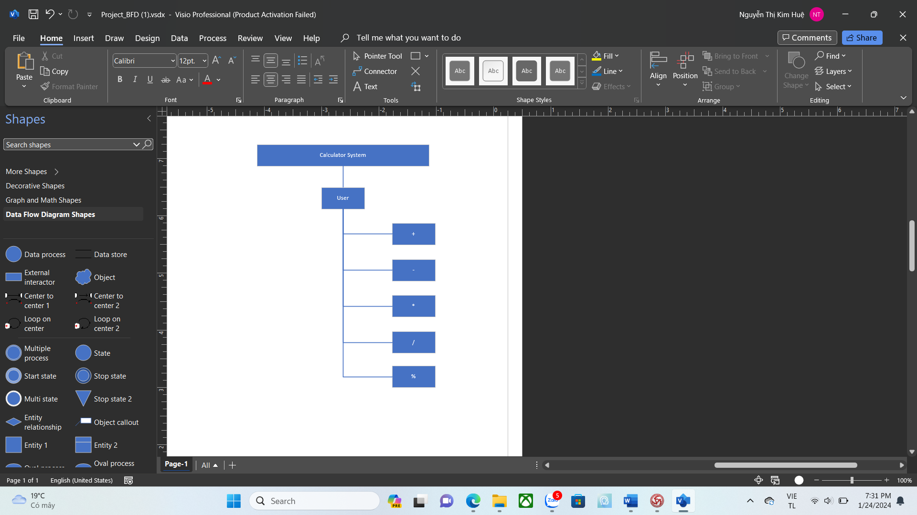

### System Context Diagram

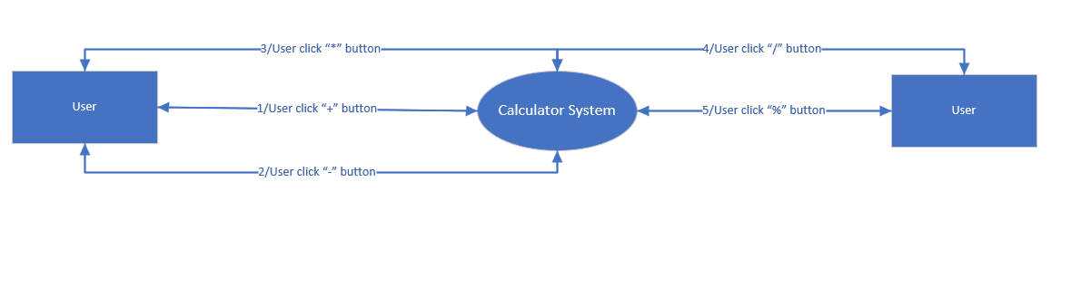

## Software Requirement Specification

### High level Functional Requirement (FR)

| FR1.1 | Title | + |
| --- | --- | --- |
| Stakeholder | Users |
| Description | The system will display 5 mathematical operations on the screen. When user click “+ “button, the system will show a form that user enters two numbers and click “Add” button to calculate their sum. |
| FR1.2 | Title | - |
| Stakeholder | Users |
| Description | The system will display 5 mathematical operations on the screen. When user click “- “button, the system will show a form that user enters two numbers and click “Sub” button to calculate their difference. |
| FR1.3 | Title | * |
| Stakeholder | Users |
| Description | The system will display 5 mathematical operations on the screen. When user click “* “button, the system will show a form that user enters two numbers and click “Multi” button to calculate their product. |
| FR1.4 | Title | / |
| Stakeholder | Users |
| Description | The system will display 5 mathematical operations on the screen. When user click “/ “button, the system will show a form that user enters two numbers and click “Division” button to calculate their quotient. |
| FR1.5 | Title | % |
| Stakeholder | Users |
| Description | The system will display 5 mathematical operations on the screen. When user click “% “button, the system will show a form that user enters two numbers and click “Mod” button to calculate their quotient but take the remainder. |

### Stakeholders

| **Stakeholder** | **Description** |
| --- | --- |
| Users | System users |

### Use case diagram

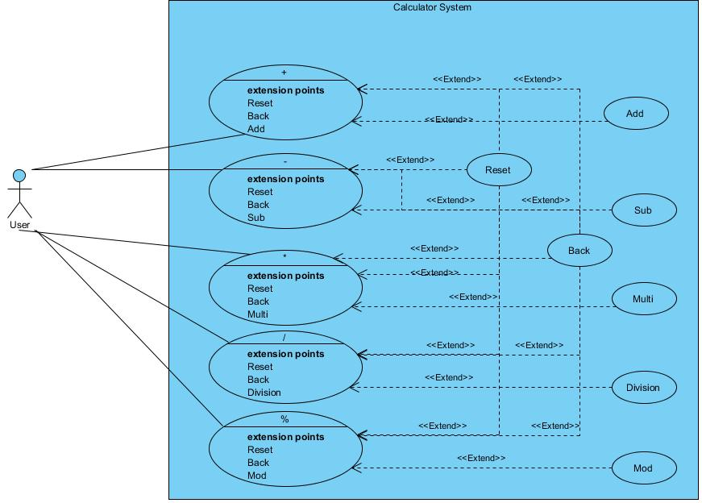

### List of use case

| **Use case ID** | **Use case name** | **Functional Req.** |
| --- | --- | --- |
| UC0.1 | Addition | FR1.1 |
| UC0.2 | Subtraction | FR1.2 |
| UC0.3 | Multiplication | FR1.3 |
| UC0.4 | Division | FR1.4 |
| UC0.5 | Mod | FR1.5 |

**2.4.5. Use Case Specification**

##### UC 01: Addition

1. Use Case Diagram

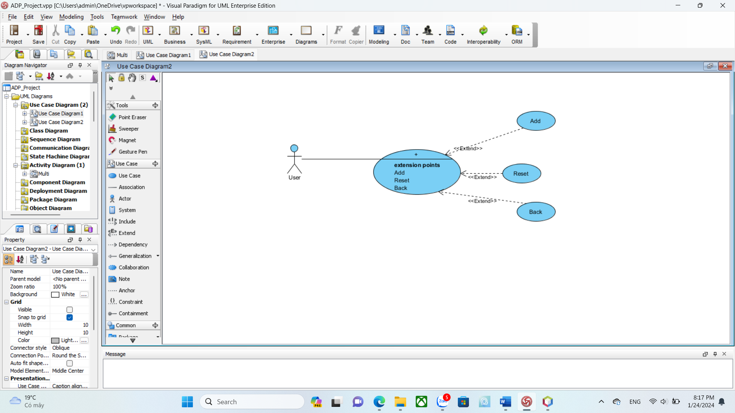

1. Use Case Specification

| Use case ID | **UC0.1** | | | | |
| --- | --- | --- | --- | --- | --- |
| Use case name | **Addition** | | | | |
| Create by | Phan Thi Thanh Huyen | | Last updated by | | Phan Thi Thanh Huyen |
| Date created | Jan 22, 2024 | | Date last updated | | Jan 22, 2024 |
| Actor | User | | | | |
| Description | This use case allows the user to know the result when adding two numbers. | | | | |
| Trigger | Click to “**+**” button on the main screen. | | | | |
| Pre-condition |  | | | | |
| Post-condition | System shows the results | | | | |
| Main Success Scenario: | **Step** | **Actor Action** | | **System Response** | |
| 1 | Chose operation “**+**” on the main screen. | | System displays the calculation form. | |
| 2 | Enter the numbers you want to calculate | |  | |
| 3 | Click “Add” button. | | The system checks the condition. | |
| 4 |  | | System shows the results. | |
|  |  | |  | |
| Alternative Scenario | **Step** | **Actor Action** | | **System Response** | |
| 3.1 |  | | The system issues a alarm message | |
| 3.2 | User confirms and returns to step 2 | |  | |
| Exceptions | **Step** | **Actor Action** | | **System Response** | |
| 5 | User click “ Reset“ button | | All values in the form will be deleted | |
| 5.1 | User returns to step 2 | |  | |
| 6 | User click “ Back “ button | | System returns main screen | |
| Priority | High | | | | |
| Business rule | N/A | | | | |

##### UC 02: Subtraction

1. Use Case Diagram

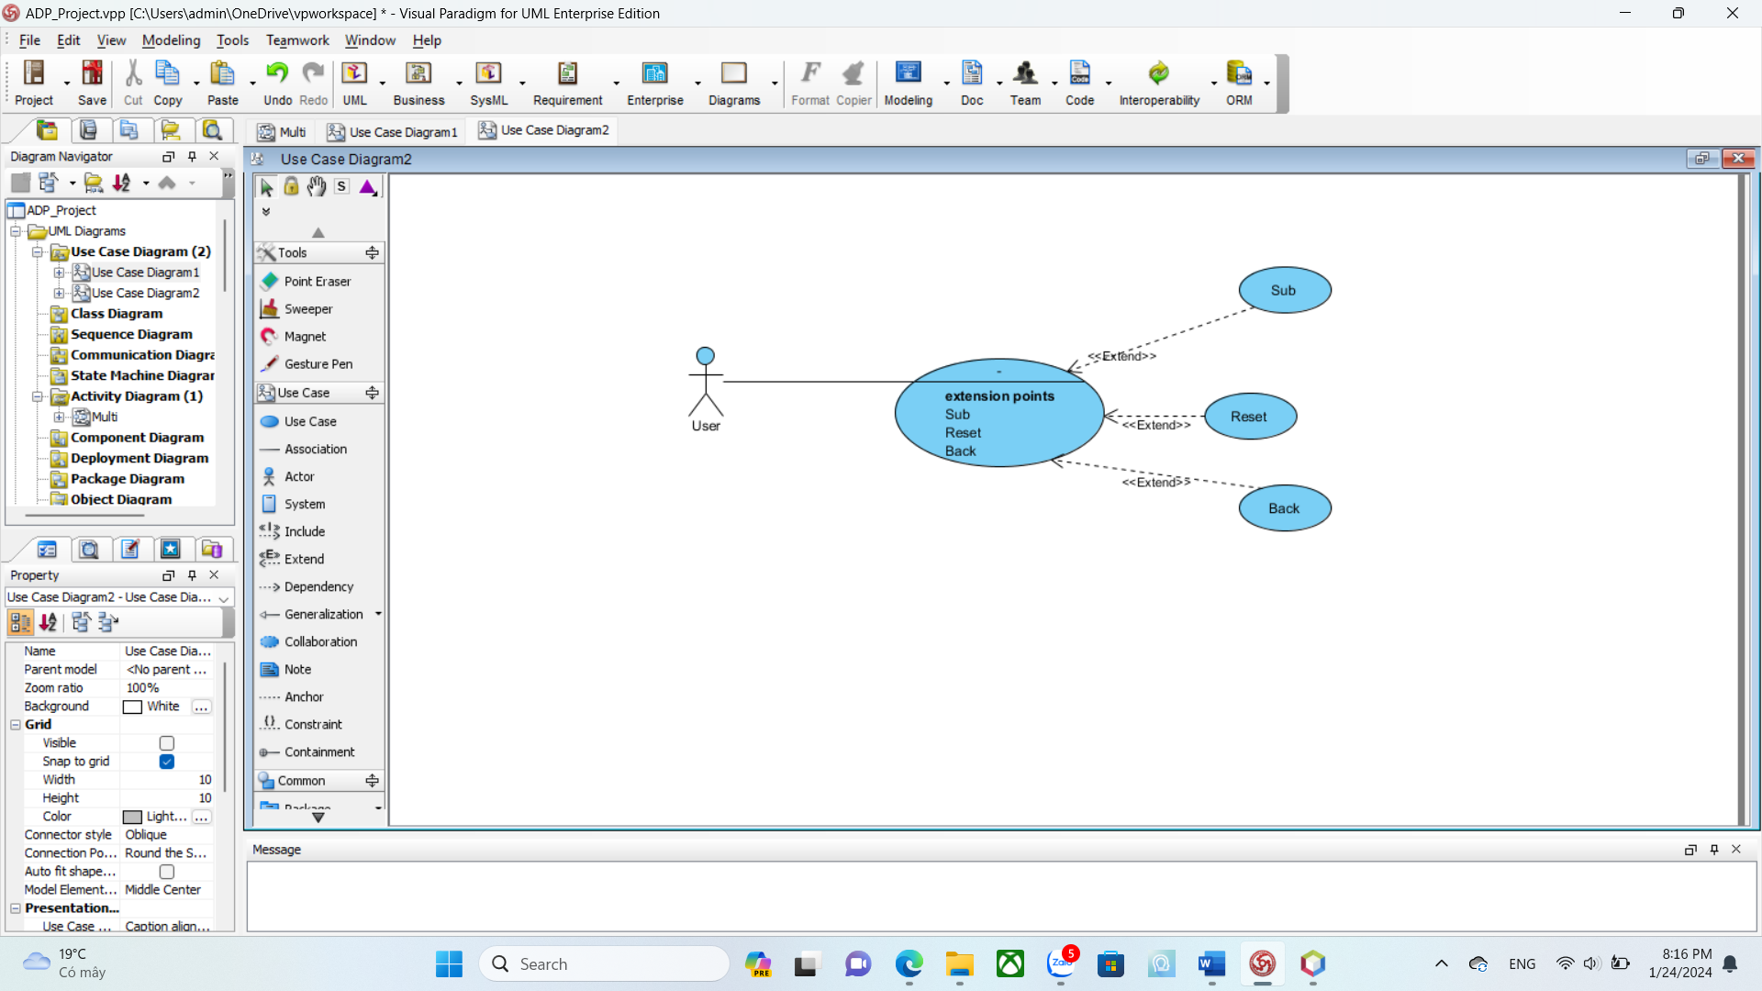

1. Use Case Specification

| Use case ID | **UC0.2** | | | | |
| --- | --- | --- | --- | --- | --- |
| Use case name | **Subtraction** | | | | |
| Create by | Tran Dinh Huy Hoang | | Last updated by | | Tran Dinh Huy Hoang |
| Date created | Jan 22, 2024 | | Date last updated | | Jan 22, 2024 |
| Actor | User | | | | |
| Description | This use case allows the user to know the result when subtracting two numbers. | | | | |
| Trigger | Click to “-” button on the main screen. | | | | |
| Pre-condition |  | | | | |
| Post-condition | System shows the results | | | | |
| Main Success Scenario: | **Step** | **Actor Action** | | **System Response** | |
| 1 | Chose operation “-” on main screen. | | System displays the calculation form. | |
| 2 | Enter the numbers you want to calculate | |  | |
| 3 | Click “Sub” button. | | The system checks the condition. | |
| 4 |  | | System shows the results. | |
|  |  | |  | |
| Alternative Scenario | **Step** | **Actor Action** | | **System Response** | |
| 3.1 |  | | The system issues a alarm message | |
| 3.2 | User confirms and returns to step 2 | |  | |
| Exceptions | **Step** | **Actor Action** | | **System Response** | |
| 5 | User click “ Reset“ button | | All values in the form will be deleted | |
| 5.1 | User returns to step 2 | |  | |
| 6 | User click “ Back “ button | | System returns main screen | |
| Priority | High | | | | |
| Business rule | N/A | | | | |

##### UC 03: Multiplication

1. Use Case Diagram

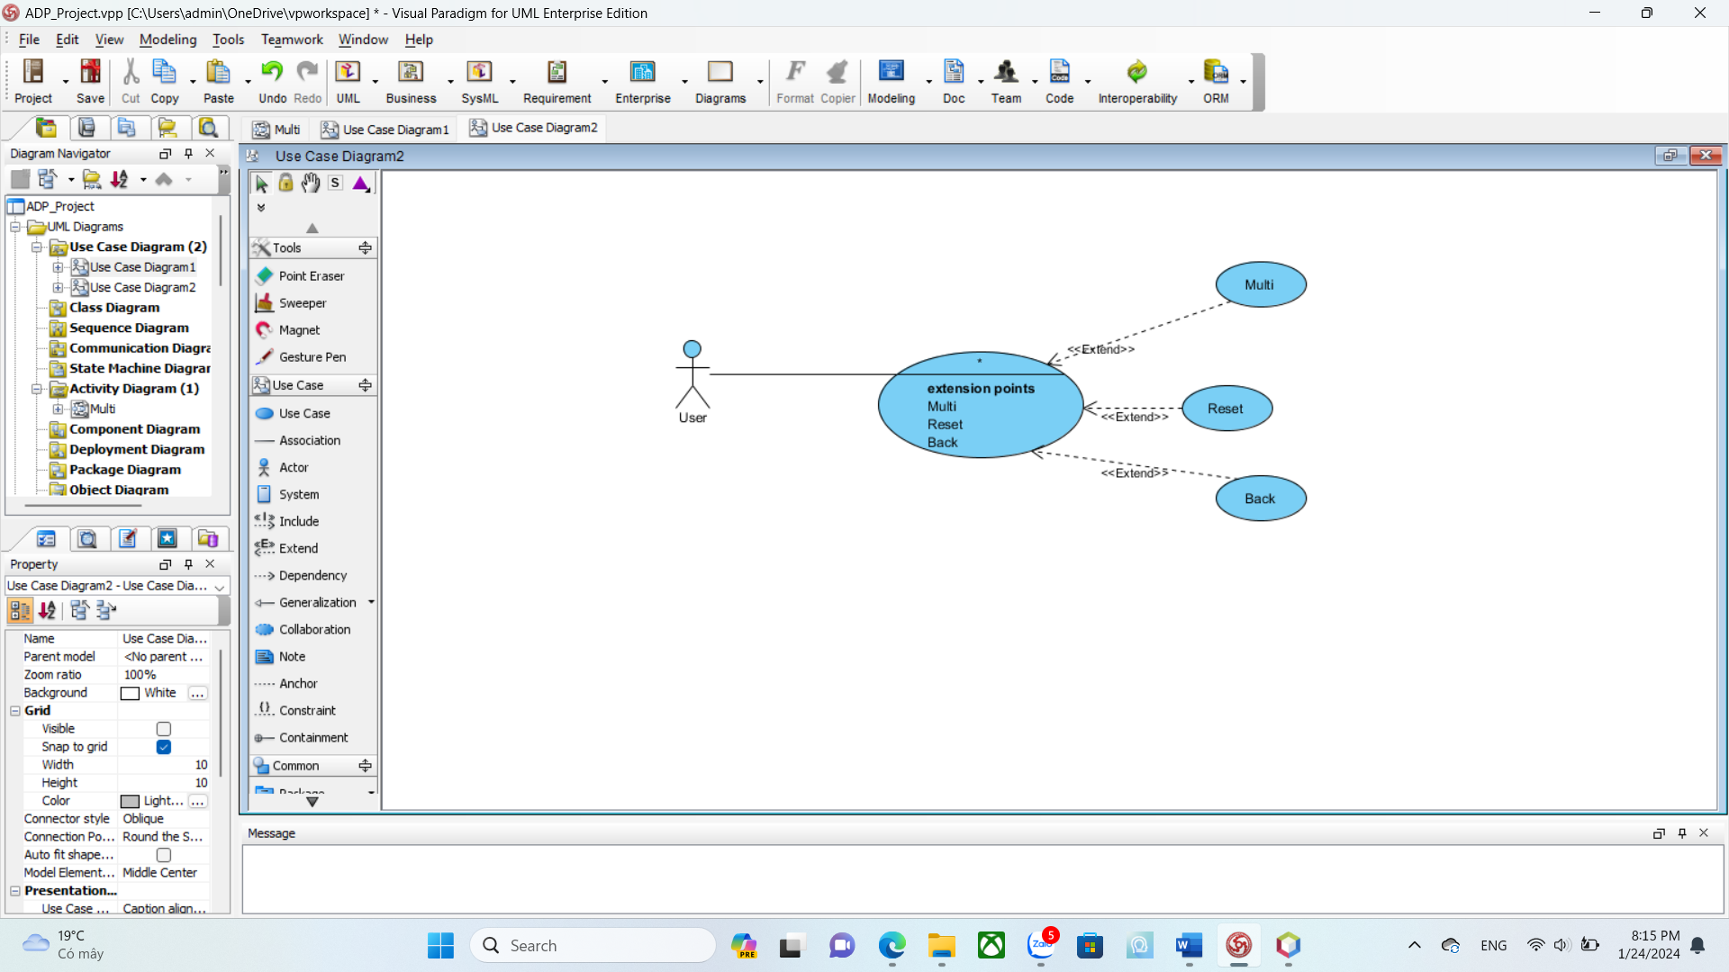

1. Use Case Specification

| Use case ID | **UC0.3** | | | | |
| --- | --- | --- | --- | --- | --- |
| Use case name | **Multiplication** | | | | |
| Create by | Vo Trung Hieu | | Last updated by | | Vo Trung Hieu |
| Date created | Jan 22, 2024 | | Date last updated | | Jan 22, 2024 |
| Actor | User | | | | |
| Description | This use case allows the user to know the result when multiplying two numbers. | | | | |
| Trigger | Click to “**\***” button on the main screen. | | | | |
| Pre-condition |  | | | | |
| Post-condition | System shows the results | | | | |
| Main Success Scenario: | **Step** | **Actor Action** | | **System Response** | |
| 1 | Chose operation “*” on the main screen. | | System displays the calculation form. | |
| 2 | Enter the numbers you want to calculate | |  | |
| 3 | Click the “Multi” button. | | The system checks the condition | |
| 4 |  | | System shows the results. | |
|  |  | |  | |
| Alternative Scenario | **Step** | **Actor Action** | |  | |
| 3.1 |  | | The system issues a alarm message | |
| 3.2 | User confirms and returns to step 2 | |  | |
| Exceptions | **Step** | **Actor Action** | | **System Response** | |
| 5 | User click “ Reset“ button | | All values in the form will be deleted | |
| 5.1 | User returns to step 2 | |  | |
| 6 | User click “ Back “ button | | System returns main screen | |
| Priority | High | | | | |
| Business rule | N/A | | | | |

##### UC 04: Division

1. Use Case Diagram

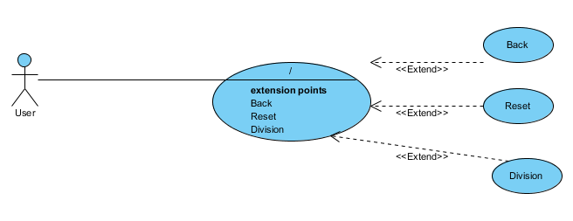

1. Use Case Specification

| Use case ID | **UC0.4** | | | | |
| --- | --- | --- | --- | --- | --- |
| Use case name | Division | | | | |
| Create by | Truong Minh Quang | | Last updated by | | Truong Minh Quang |
| Date created | Jan 22, 2024 | | Date last updated | | Jan 22, 2024 |
| Actor | User | | | | |
| Description | This use case allows the user to know the quotient when dividing two numbers. | | | | |
| Trigger | Click to “**/**” button on main screen. | | | | |
| Pre-condition |  | | | | |
| Post-condition | System shows the results | | | | |
| Main Success Scenario: | **Step** | **Actor Action** | | **System Response** | |
| 1 | Chose operation “/” on main screen. | | System displays the calculation form. | |
| 2 | Enter the numbers you want to calculate | |  | |
| 3 | Click “Division” button. | | The system checks the condition | |
| 4 |  | | System shows the results. | |
|  |  | |  | |
| Alternative Scenario | **Step** | **Actor Action** | | **System Response** | |
| 3.1 |  | | The system issues a alarm message | |
| 3.2 | User confirms and returns to step 2 | |  | |
| Exceptions | **Step** | **Actor Action** | | **System Response** | |
| 5 | User click “ Reset“ button | | All values in the form will be deleted | |
| 5.1 | User returns to step 2 | |  | |
| 6 | User click “ Back “ button | | System returns main screen | |
| Priority | High | | | | |
| Business rule | N/A | | | | |

##### UC 05: Mod

1. Use Case Diagram

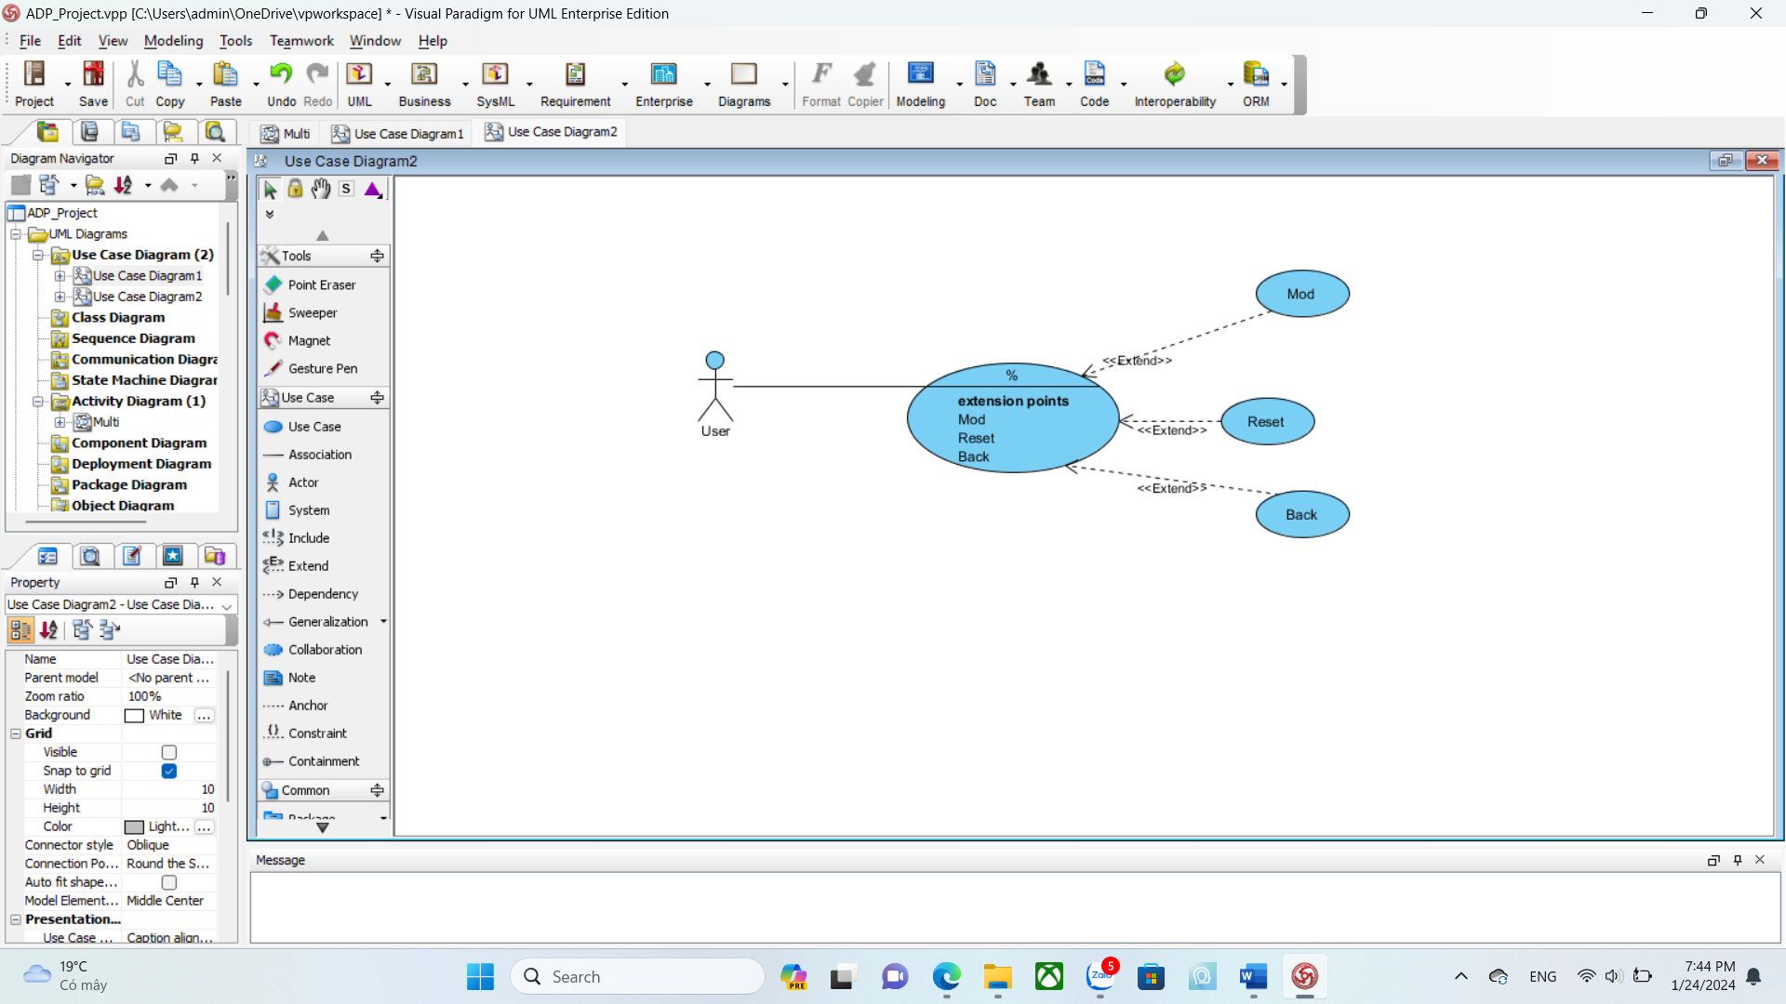

1. Use Case Specification

| Use case ID | **UC0.5** | | | | |
| --- | --- | --- | --- | --- | --- |
| Use case name | Mod | | | | |
| Create by | Nguyen Thi Kim Hue | | Last updated by | | Nguyen Thi Kim Hue |
| Date created | Jan 22, 2024 | | Date last updated | | Jan 22, 2024 |
| Actor | User | | | | |
| Description | This use case allows the user to know the remainder when dividing two numbers. | | | | |
| Trigger | Click the “**%**” button on the main screen. | | | | |
| Pre-condition |  | | | | |
| Post-condition | System shows the results | | | | |
| Main Success Scenario: | **Step** | **Actor Action** | | **System Response** | |
| 1 | Choose operation “%” on main screen. | | System displays the calculation form. | |
| 2 | Enter the numbers you want to calculate | |  | |
| 3 | Click “Mod” button. | | The system checks the condition | |
| 4 |  | | System shows the results. | |
|  |  | |  | |
| Alternative Scenario | **Step** | **Actor Action** | | **System Response** | |
| 3.1 |  | | The system issues a alarm message | |
| 3.2 | User confirms and returns to step 2 | |  | |
| Exceptions | **Step** | **Actor Action** | | **System Response** | |
| 5 | User click “ Reset“ button | | All values in the form will be deleted | |
| 5.1 | User returns to step 2 | |  | |
| 6 | User click “ Back “ button | | System returns main screen | |
| Priority | High | | | | |
| Business rule | N/A | | | | |

## 2.4.6 . Activity Diagrams

## 2.4.6.1. Addition

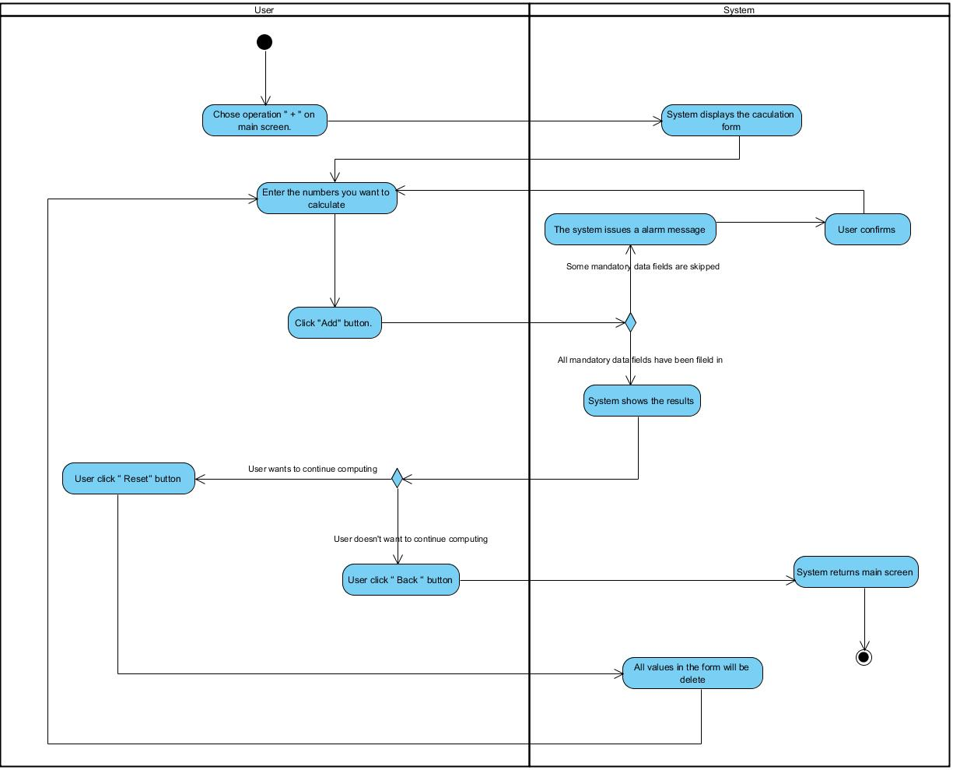

## 2.4.6.2. Subtraction

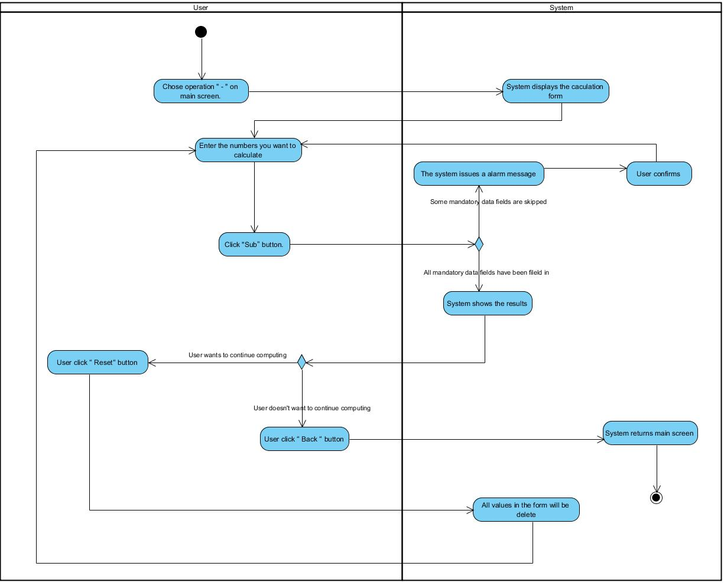

## 2.4.6.3. Multiplication

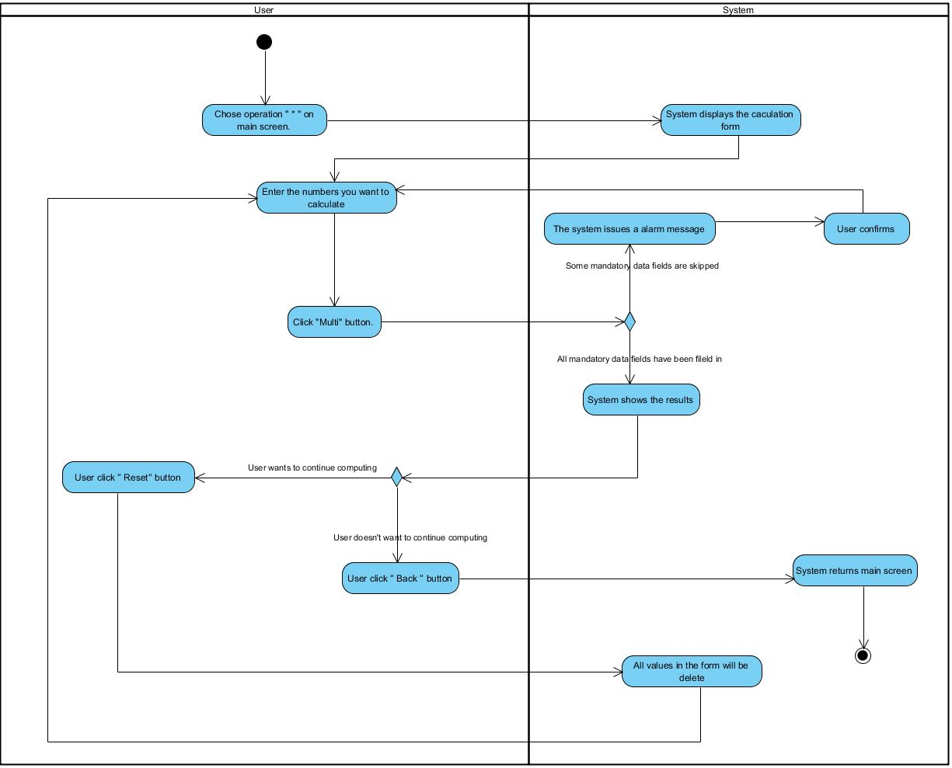

## 2.4.6.4. Division

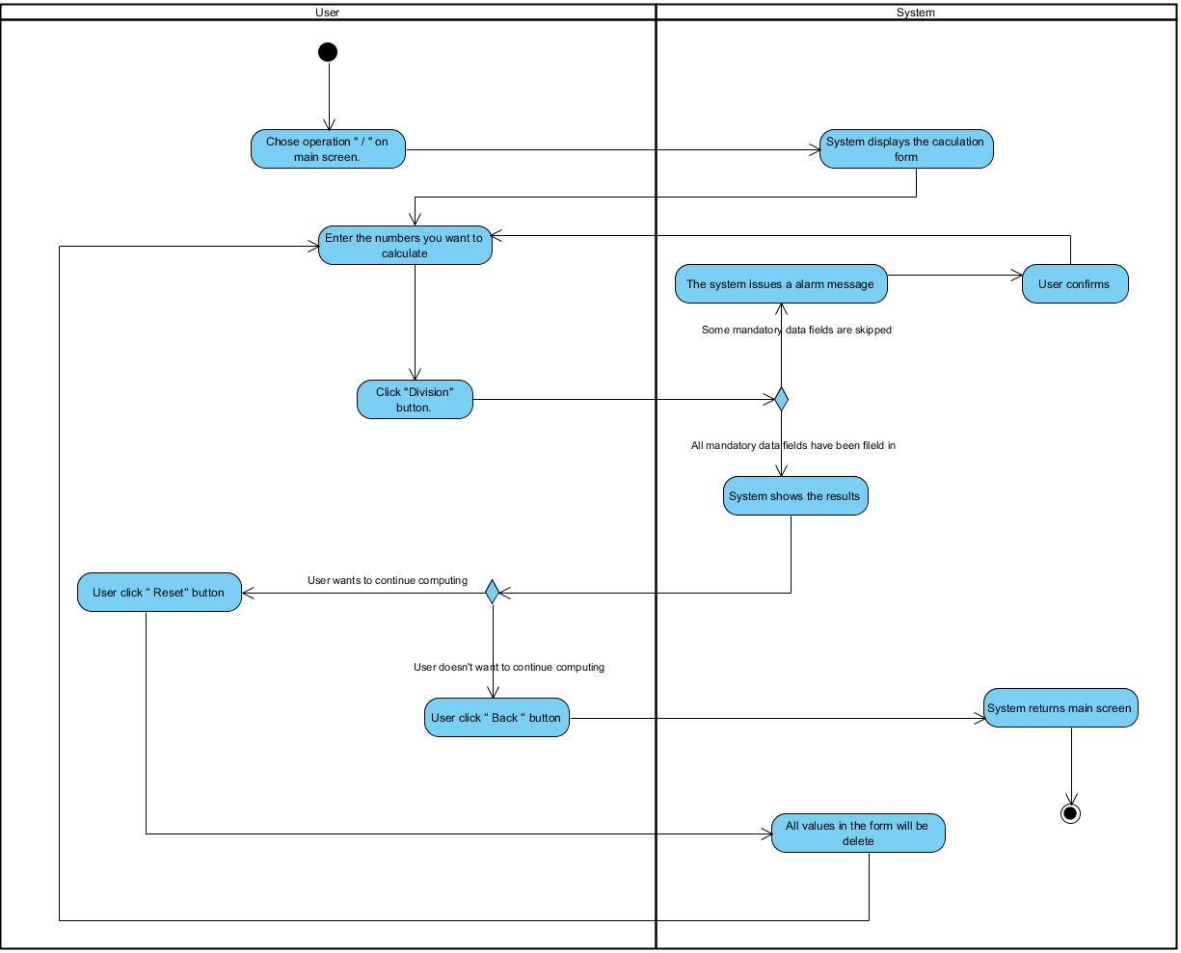

## 2.4.6.5. Mod

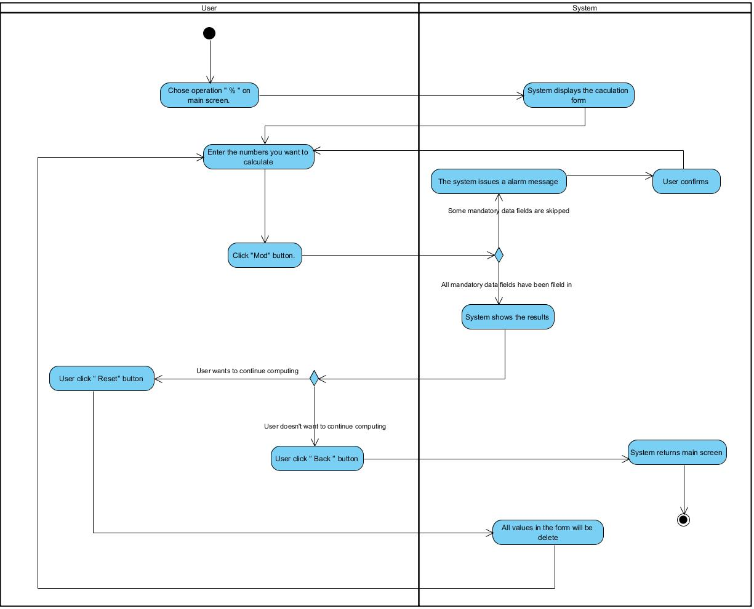

# Appendix A: Glossary

| FR | Functional Requirement |
| --- | --- |
| QA | Quality Attribute |
| UC | Use case |
| BR | Business rule |